***Cost Function or Error Function***

***( Notebook mai achese kiya hoon )***

*Y = mx+b*

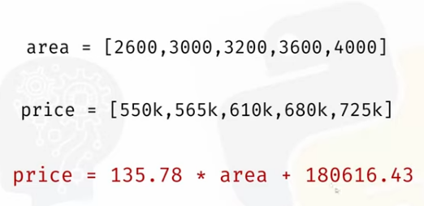

***Y = mx +b***

***X = area hai***

*Equation ko bolte hai Prediction function*

*Koi bhi random line plot krke*

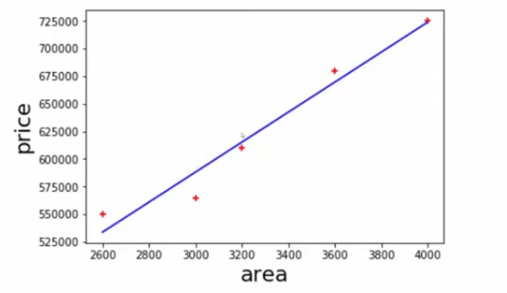

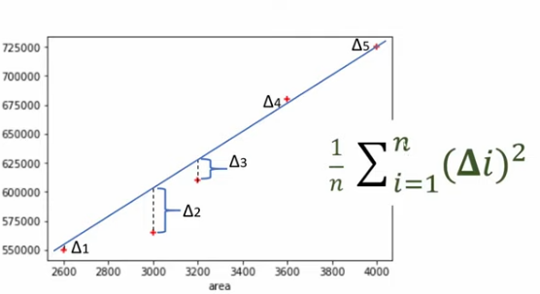

***Fir delta nikalo basically difference between***

***Predicted y & actual Y***

***Fir MSE milta hai humme***

***MSE ko hie cost function bhi bollte hai..***

***Jo MSE find krneke Algo ko Gradient Descent bollte hai***